Moonlight Hall

Description: Moonlight hall is a 2 floor suite-style dorm that can fit up to 30 students.

Room assignments consist of single large rooms (room completely to yourself) and double large rooms (a single large room shared with one roommate. This dorm is best for people who prefer smaller communities and like bigger room space.

Image:

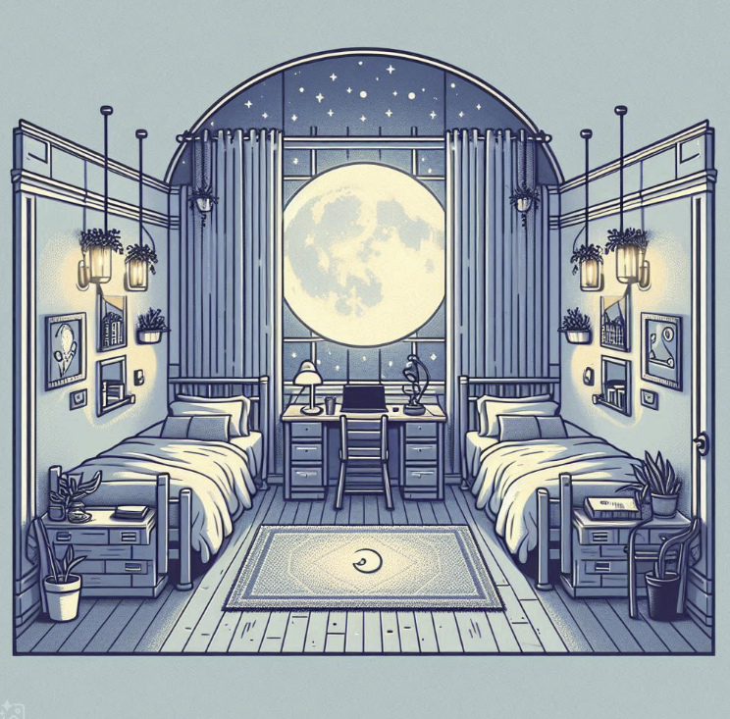

Eclipse Hall:

Description: Eclipse hall is a 4 floor tower-style dorm that can fit up to 60 students.

Room assignments consist of singles and doubles, where each floor consists of 10 different rooms. This dorm is best for people who prefer an apartment style of living

Image

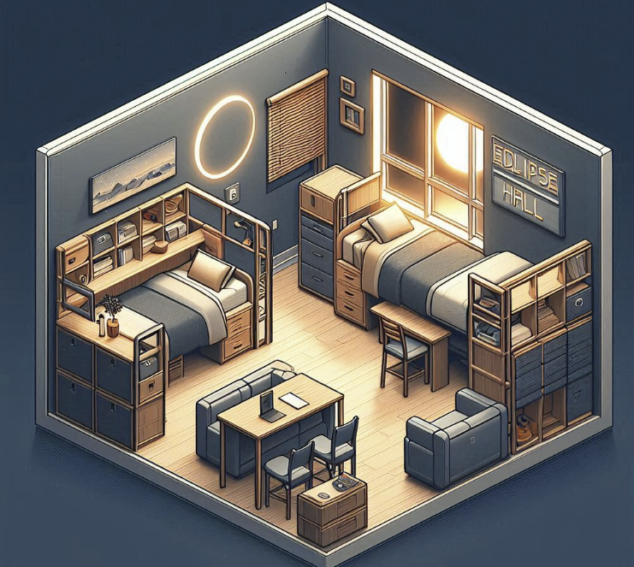

Comet Hall

Description: Comet hall is the largest dorm building, with up to 2 floors of several different suite-style rooms, this dorm can fit up to 210 students.

Room assignments consist of doubles, triples, quads and even quints. This dorm is best for people who prefer larger communities.

Image:



Solstice Hall:

Description: Solstice hall is a 6 floor tower-style dorm that can fit up to 45 students.

Room assignments consist of singles and doubles, where each floor consists of 5 different rooms. This dorm is best for people who prefer an apartment style of living and like smaller spaces.

Image:

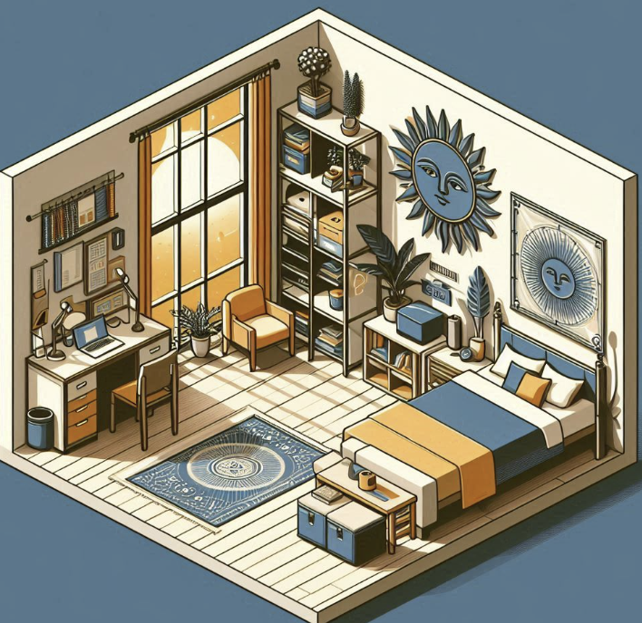

Aurora Hall

Description: Aurora hall is a 5 floor tower-style dorm that can fit up to 100 students.

Room assignments consist of singles, doubles, triples and quads, where each floor consists of 8 different rooms.

Image:

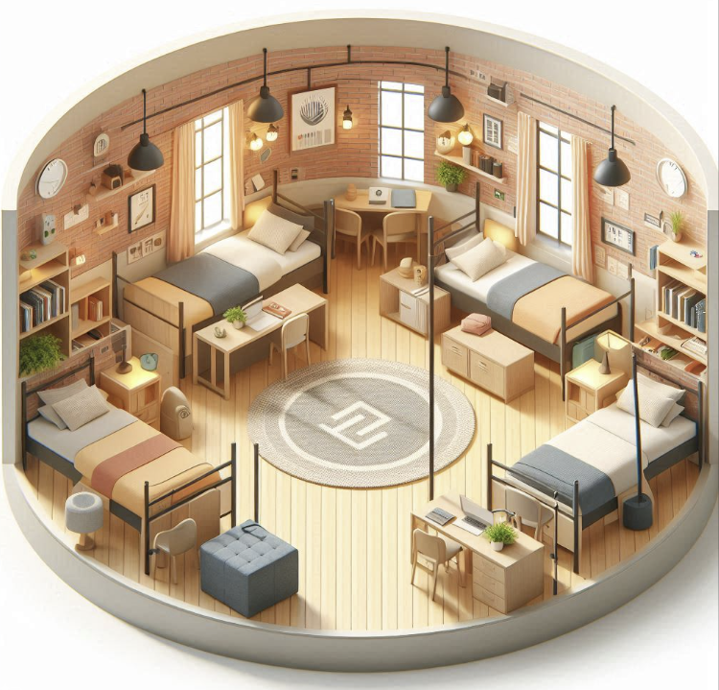

Nebula Hall

Description: Nebula hall is the second largest dorm, with up to 2 floors of several different suite-style rooms, this dorm can fit up to 140 students.

Room assignments consist of triples and quads.

Image:

